**Assignment – Student Information System (SISDB) Output Screenshots**

Task 1

Students table

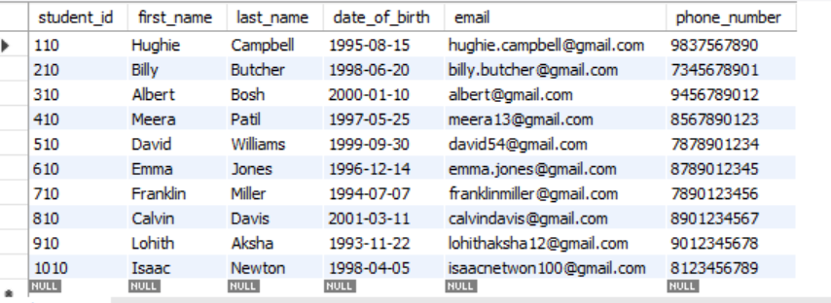

Courses table

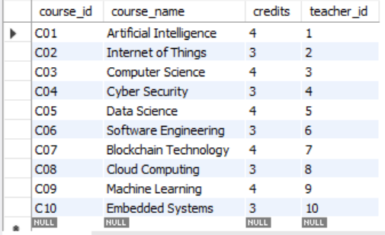

Teacher table

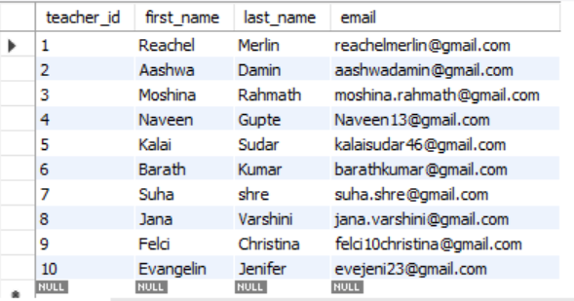

Enrollments table

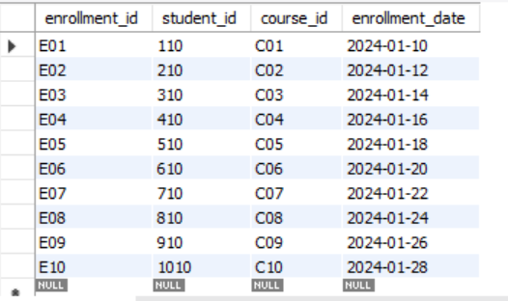

Payments table

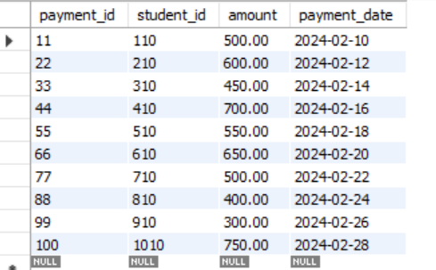

Er diagram

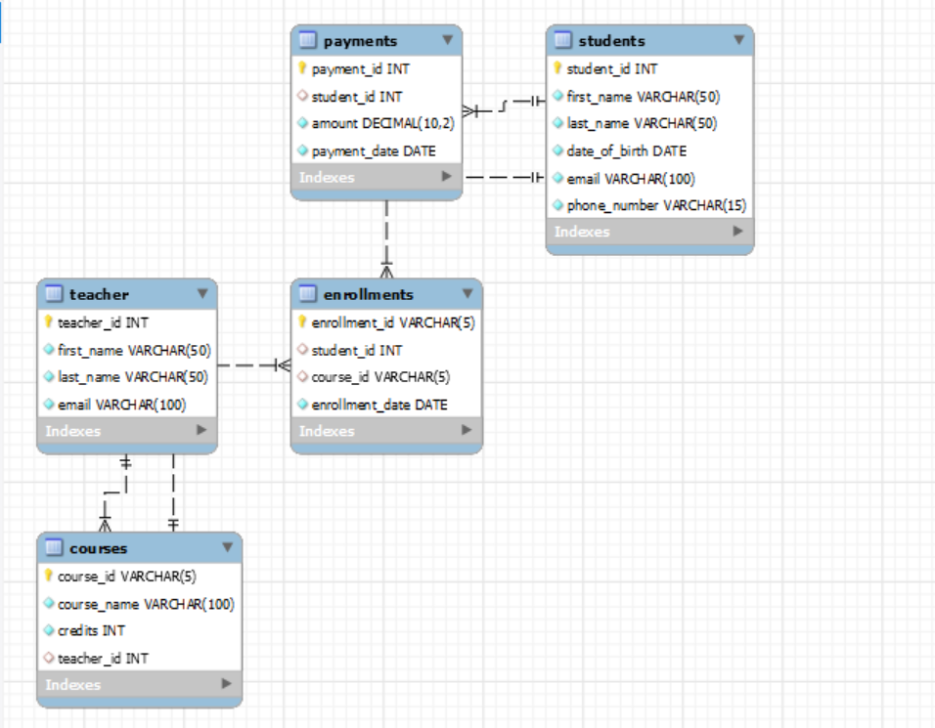

**Task 2 - Select, Where, Between, AND, LIKE:**

1) insert into Students (student_id,first_name, last_name, date_of_birth, email, phone_number) values(1011, 'Firthose', 'Banu', '1995-08-15', 'firthosebanu@example.com', '7564667890');

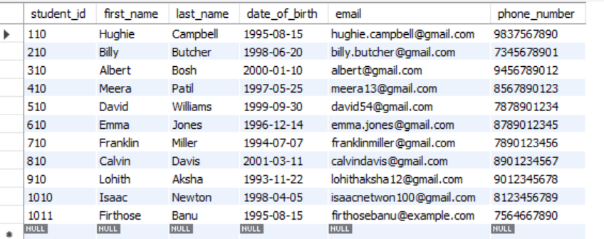

2) insert into Enrollments (enrollment_id, student_id, course_id, enrollment_date) values ('E11', 1011, 'C01', '2024-03-01');

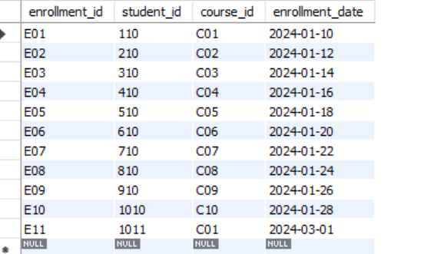

3) update Teacher set email = 'hello.reachelmerlin@gmail.com'

WHERE teacher_id = 1;

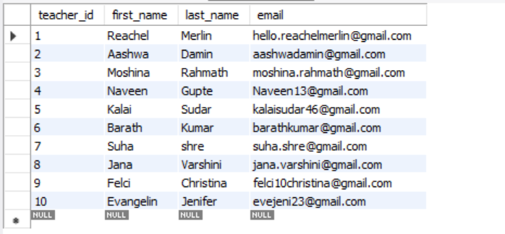

4) delete from Enrollments where student_id = 110 and course_id = 'C01';

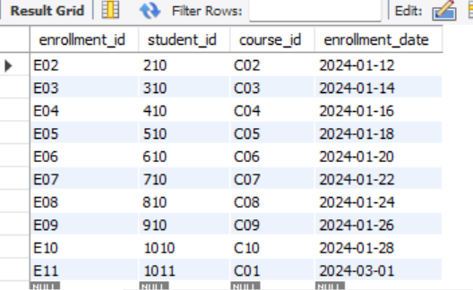

5) update Courses set teacher_id = 2where course_id = 'C09';

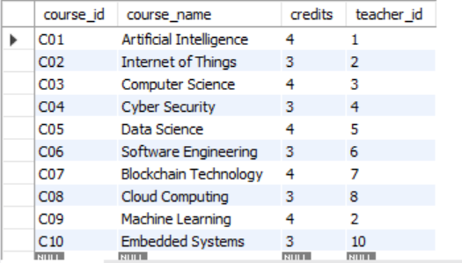

6) Delete a specific student and remove their enrollments (Deleting Student ID 210)

delete from Payments where student_id = 210;

delete from Enrollments where student_id = 210;

delete from Students where student_id = 210;

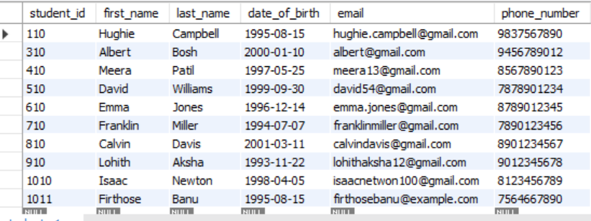

7) update Payments set amount = 750.00 where payment_id = 22;

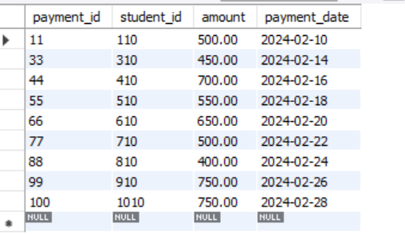

**Task 3. Aggregate functions, Having, Order By, GroupBy and Joins:**

1. select s.student_id, s.first_name, s.last_name, sum(p.amount) as total_payment from students s join payments p on s.student_id = p.student_id where s.student_id = 110 group by s.student_id, s.first_name, s.last_name;



1. select c.course_id, c.course_name, count(e.student_id) as student_count from courses c left join enrollments e on c.course_id = e.course_id group by c.course_id, c.course_name order by student_count desc;

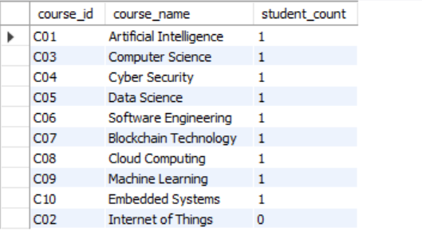

3) select s.student_id, s.first_name, s.last_name from students s left join enrollments e on s.student_id = e.student_id where e.student_id is null;



4) select s.first_name, s.last_name, c.course_name from students s join enrollments e on s.student_id = e.student_id join courses c on e.course_id = c.course_id;

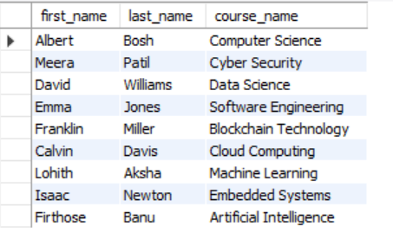

5) SELECT t.first_name, t.last_name, c.course_name FROM Teacher tJOIN Courses c ON t.teacher_id = c.teacher_id;

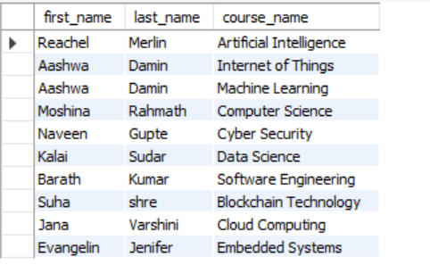

6) select s.first_name, s.last_name, e.enrollment_date from students s

join enrollments e on s.student_id = e.student_id join courses c on e.course_id = c.course_idwhere c.course_name = 'artificial intelligence'

order by e.enrollment_date;



7) select s.student_id, s.first_name, s.last_name from students s left join payments p on s.student_id = p.student_id where p.student_id is null;

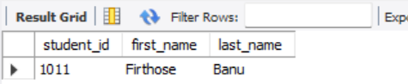

8) select c.course_id, c.course_name from courses c left join enrollments e on c.course_id = e.course_idwhere e.course_id is null;



9) select e.student_id, s.first_name, s.last_name, count(e.course_id) as num_of_courses from enrollments e join students s on e.student_id = s.student_id group by e.student_id, s.first_name, s.last_name having num_of_courses > 1;



10) select t.teacher_id, t.first_name, t.last_name from teacher t left join courses c on t.teacher_id = c.teacher_id where c.teacher_id is null;



**Task 4. Subquery and its type:**

1) select avg(student_count) as avg_students_per_course from ( select course_id, count(student_id) as student_count from enrollments group by course_id) as course_enrollments;

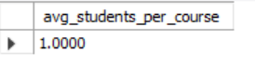

2) select student_id, first_name, last_name from students where student_id in (select student_id from payments where amount = (select max(amount) from payments);

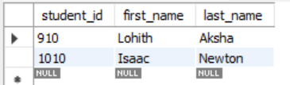

3) select avg(student_count) as average_enrollment from (select course_id, count(student_id) as student_count from enrollments group by course_id) as course_enrollments;

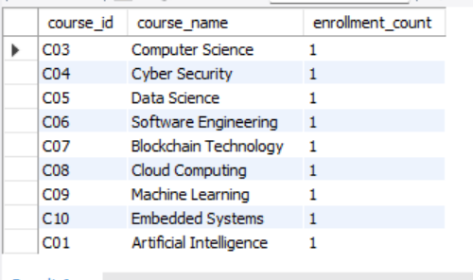

4) select t.teacher_id, t.first_name, t.last_name, (select sum(p.amount) from payments p join enrollments e on p.student_id = e.student_id join courses c on e.course_id = c.course_idwhere c.teacher_id = t.teacher_id) as total_payments from teacher t;

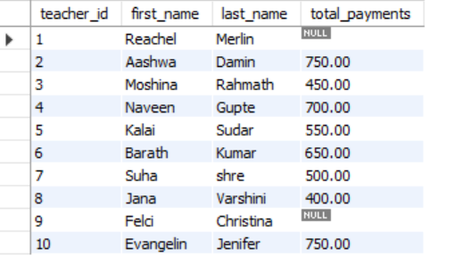

5) select s.student_id, s.first_name, s.last_name from students s where (select count(distinct course_id) from enrollments where student_id = s.student_id) = (select count(*) from courses);



6) select teacher_id, first_name, last_name from teacher where teacher_id not in (select distinct teacher_id from courses);

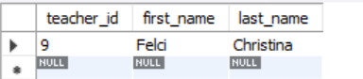

7) select avg(age) as average_age from (select datediff(curdate(), date_of_birth) / 365 as age from students) as age_subquery;

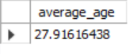

8) select course_id, course_name from courses where course_id not in (select distinct course_id from enrollments);

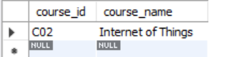

9) select s.student_id, s.first_name, s.last_name, c.course_name, (select sum(p.amount) from payments p where p.student_id = s.student_id) as total_payment from students s join enrollments e on s.student_id = e.student_id join courses c on e.course_id = c.course_id;

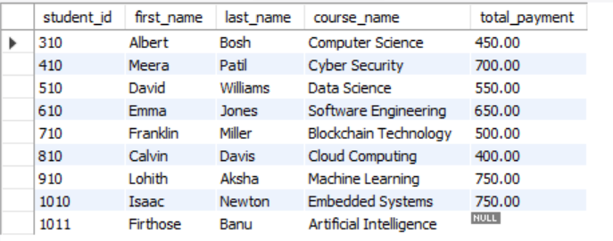

10) select student_id, first_name, last_name from students where student_id in select student_idfrom payments group by student_idhaving count(payment_id) > 1);



11) select s.student_id, s.first_name, s.last_name, sum(p.amount) as total_payments from students s join payments p on s.student_id = p.student_id group by s.student_id;

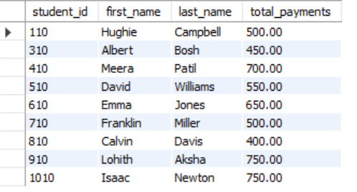

12) select c.course_name, count(e.student_id) as student_count from courses c left join enrollments e on c.course_id = e.course_id group by c.course_name;

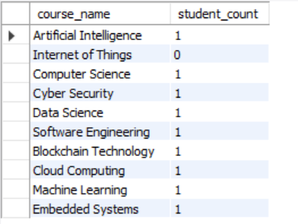

13) select s.student_id, s.first_name, s.last_name, avg(p.amount) as avg_payment from students join payments p on s.student_id = p.student_id group by s.student_id;

